**LEARN - U – ONLINE**

1. Introduction

* In this project features are most emerging Technology and courses going to add and through this learning platform the end-users or students can able to career and passion.
* This project is about completely learning all the courses in online at LEARN – U – ONLINE website.

1. User Interface Design and Prototype

* User can easy to assess the web-page and learn more from there.

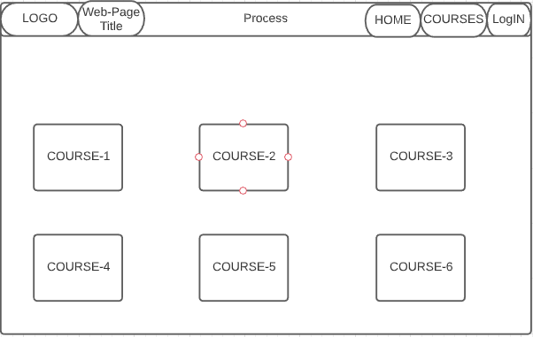

1. Navigation Structure

* In this project navigations are placed at open-top of the web page and it easy to assess.

1. References

* W3school web-site
* Udemy web-site